Q1

PROGRAMME

#include<iostream>

using namespace std;

int stack[100], n=100, top=-1;

void isfull(){

if (top>=n-1){

cout<<"STACK IS FULL"<<endl;

}

else

{

cout<<"STACK IS NOT FULL"<<endl;

}

}

void push(int val){

top++;

stack[top]=val;

}

void isempty(){

if (top<=-1){

cout<<"STACK IS EMPTY"<<endl;

}

else

{

cout<<"STACK IS NOT EMPTY"<<endl;

}

}

void pop(){

cout<<"THE POPPED ELEMENT IS: "<<stack[top]<<endl;

top--;

}

void peek(){

cout<<"THE TOP ELEMENT IS: "<<stack[top]<<endl;

}

void display(){

if(top>=0){

cout<<"STACK ELEMENTS ARE: ";

for(int i=top; i>=0; i--){

cout<<stack[i]<<" ";

cout<<endl;

}

}

else

{

cout<<"THE STACK IS EMPTY";

}

}

int main(){

int ch, val;

cout<<"------------------------------------------------------"<<endl;

cout<<"1) PUSH IN STACK"<<endl;

cout<<"2) POP IN STACK"<<endl;

cout<<"3) CHECK IF STACK IS FULL OR NOT?"<<endl;

cout<<"4) CHECK IF STACK IS EMPTY OR NOT?"<<endl;

cout<<"5) DISPLAY STACK"<<endl;

cout<<"6) PEEK STACK"<<endl;

cout<<"7) EXIT"<<endl;

cout<<"------------------------------------------------------"<<endl;

do

{

cout<<"ENTER THE CHOICE: "<<endl;

cin>>ch;

switch(ch)

{

case 1:

{

cout<<"ENTER THE ELEMENT TO BE PUSHED"<<endl;

cin>>val;

push(val);

break;

}

case 2:

{

pop();

break;

}

case 3:

{

isfull();

break;

}

case 4:

{

isempty();

break;

}

case 5:

{

display();

break;

}

case 6:

{

peek();

break;

}

case 7:

{

cout<<"EXIT"<<endl;

break;

}

default:

{

cout<<"INVALID CHOICE"<<endl;

}

}

}

while(ch!=7);

return 0;

}

OUTPUT

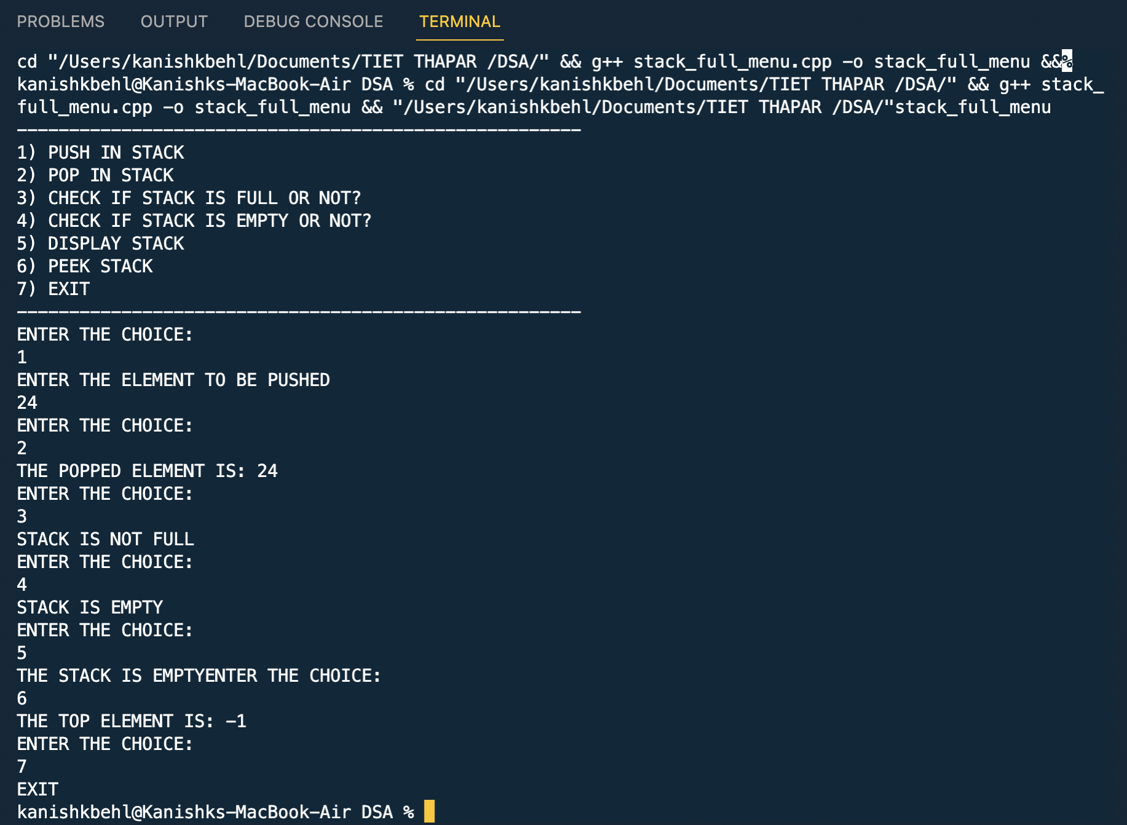

Q2

PROGRAMME

#include<iostream>

#include<string>

using namespace std;

int stack[100], n=100, top=-1;

char push(char val){

if(top>=n-1)

{

cout<<"THE STACK IS FULL"<<endl;

}

else

{

top++;

stack[top]=val;

}

}

char pop(){

if(top<=-1)

{

cout<<"THE STACK IS EMPTY"<<endl;

}

else

{

return stack[top--];

}

}

int main(){

*string* s;

getline(cin,s);

*// cout<<s.length();*

for(int i=0; i<s.length(); i++)

{

push(s[i]);

}

for(int i=0; i<s.length(); i++)

{

s[i]=pop();

}

cout<<"THE REVERSING STRING IS: "<<s<<endl;

return 0;

}